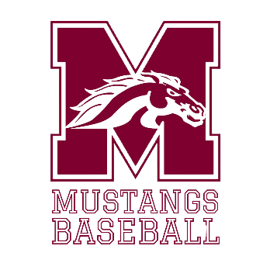

**2025 MONTFORD BASEBALL**

**TRYOUT INFORMATION**

**DATES**

Tryouts will be on **Wednesday, October 8th (PITCHERS AND CATCHERS ONLY), Thursday, October 9th (ALL PLAYERS) and Friday, October 10th (ALL PLAYERS).** After tryouts, practice will be every day except Saturday & Sunday unless otherwise specified by the district.

**TIMES**

**Tryouts will begin at 5:30pm each day and will conclude by 7/8:30 PM (depending on the day, check the tryout schedule form to know which days).** Players will be split into multiple groups (amounts TBD) due to high volume. Players may arrive beginning at **4:30/5:00pm** to the designated location for that day whether it will be at Chiles high school baseball field, Lincoln baseball field, or the Montford baseball field directly above the gym. Players should be picked up no later than **7:45 pm on the 8th and 9th and 8:45 pm on the 10th**.

**REQUIREMENTS**

**ALL** players must have a current, active physical, HIPPA form and Activity Participation form on file in the Aktivate Portal System before they are allowed to tryout. Each form is posted on the Montford Athletics and Montford Baseball website.

**ALL** players must have a **minimum 2.0 GPA** in order to be able to tryout.

**DRESS**

Players will wear their own baseball pants, t-shirts/jersey and cleats (molded or metal) through all three days of tryouts. Basketball or tennis shoes should also be brought for indoor work just in case of weather (**NO** crocs, hey dudes, sperrys, slides etc.) if your child is wearing any of these they will not participate. Beginning the following weeks, some team issued gear will be provided (practice shirts/shorts) by the program. Players will still need to provide their own baseball pants and cleats for practices. Cleats should be black or white only.

**WEATHER**

Weather **WILL** impact tryouts. Anytime a lightning strike occurs within 10 miles of our campus, the staff receives a digital alert with a time frame with which we are REQUIRED to go indoors for safety. When this occurs, practice will ***not*** conclude early as we have access to the gym to continue how we can.

**ROSTER SIZE/CUTS**

Even though Middle School baseball teams have a roster cap of **(20)** players at the direction of ***the Leon County School District Administration*** that does ***NOT*** mean we will keep that many players. Montford’s baseball program will keep the number of players deemed beneficial to the success and direction of the program. Montford Baseball had more than **90** at tryouts in 2024 and expects to meet or exceed that number this year. Tryouts will be highly competitive. Cuts will be made and the final roster posted following the tryout days. The roster will be posted to the Montford Baseball Website.

**The Montford Baseball Coaching Staff will gladly meet with any *player* who did not make the final roster. Emails and/or calls from parents will not be responded to until the player has met with the coaching staff first.**

**ATTENDANCE**

All players are expected to be **on time** for all practices. Players will be evaluated based upon the skills they display ***when present only***. A player who has a family obligation or other issue that prevents them from attending all tryouts will have less opportunity to prove themselves prior to the cut date.

Once the final roster is determined, players are expected at every team function until the conclusion of the season.

**VIEWING TRYOUTS**

Parents & family are permitted and welcomed to watch tryouts from the bleachers at the Highschool field we are at for the day and the concrete sidewalks beside the baseball field (when at Montford). Parents are not permitted on the field, in the weight room or gym (when at Montford). Coaches will not speak with parents outside of an injury or eligibility/clearance situation during tryouts for any reason.

*Note that baseball tryouts are planned and constructed for* ***skill evaluation*** *and not as a normal practice*.

**PARENT MEETING**

For those who make the final roster, there will be a mandatory parent meeting on **Monday, October 13th at 6:15-7:00 in the Montford Weightroom in the gym**. This meeting will last 45 minutes and provide vital information and answer questions for the direction and goals of the baseball program.